Proxy Chain hiding in the Network with multiple IP addresses

Youtube Video
https://www.youtube.com/watch?v=qsA8zREbt6g

10101010101010101010101010101101001000000

Open Tor Browser In Kali LInux
1111111
sudo apt update
22222222
sudo apt install torbrowser-launcher
33333333333
proxychains4 torbrowser-launcher

2222222222222222222222Start tor to connect to the Internet22222222222222
Start Tor Internet
sudo systemctl start tor
Check if the Internet Connection ist there
ss -lntp | grep 9150
Start search
proxychains4 -f /etc/proxychains4.conf firefox https://www.google.de

222222222
Put in the front proxychains4 and then the text
proxychains4 gobuster dir -u https://www.minecraftdata.info/ -w /usr/share/wordlists/dirb/common.txt
proxychains4 gobuster dir -u https://www.minecraftdata.info/ -w /usr/share/wordlists/dirb/common.txt
proxychains4 nmap -sT -Pn -n -p 80,443 <ZIEL-IP>
proxychains4 msfvenom ...
proxychains4 nmap -sT -Pn -n -p 80,443 192.168.178.106
proxychains4 -f /etc/proxychains4.conf firefox
proxychains4 -f /etc/proxychains4.conf firefox
proxychains4 -f /etc/proxychains4.conf firefox https://www.google.de
proxychains4 -f /etc/proxychains4.conf firefox https://www.google.de
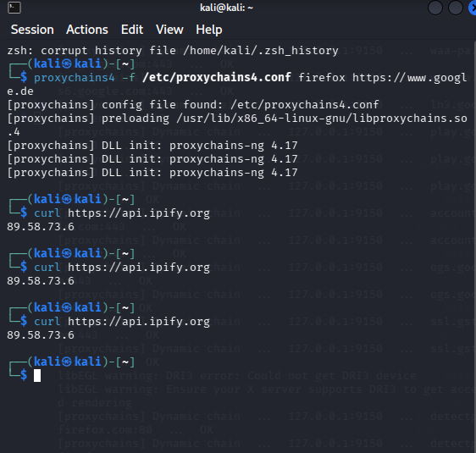
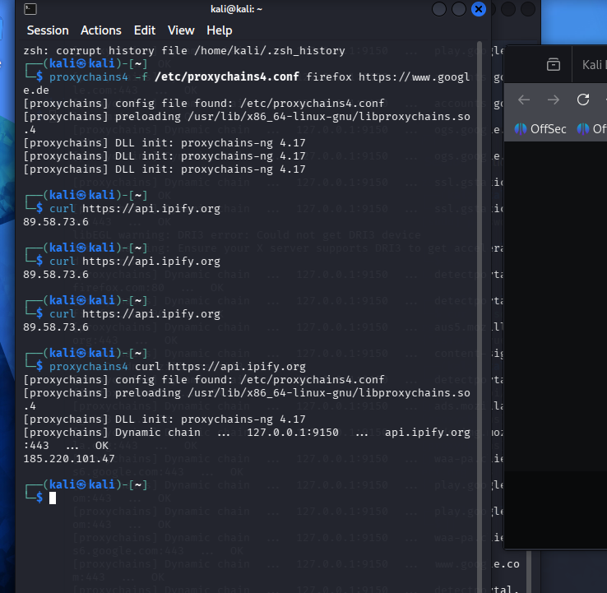

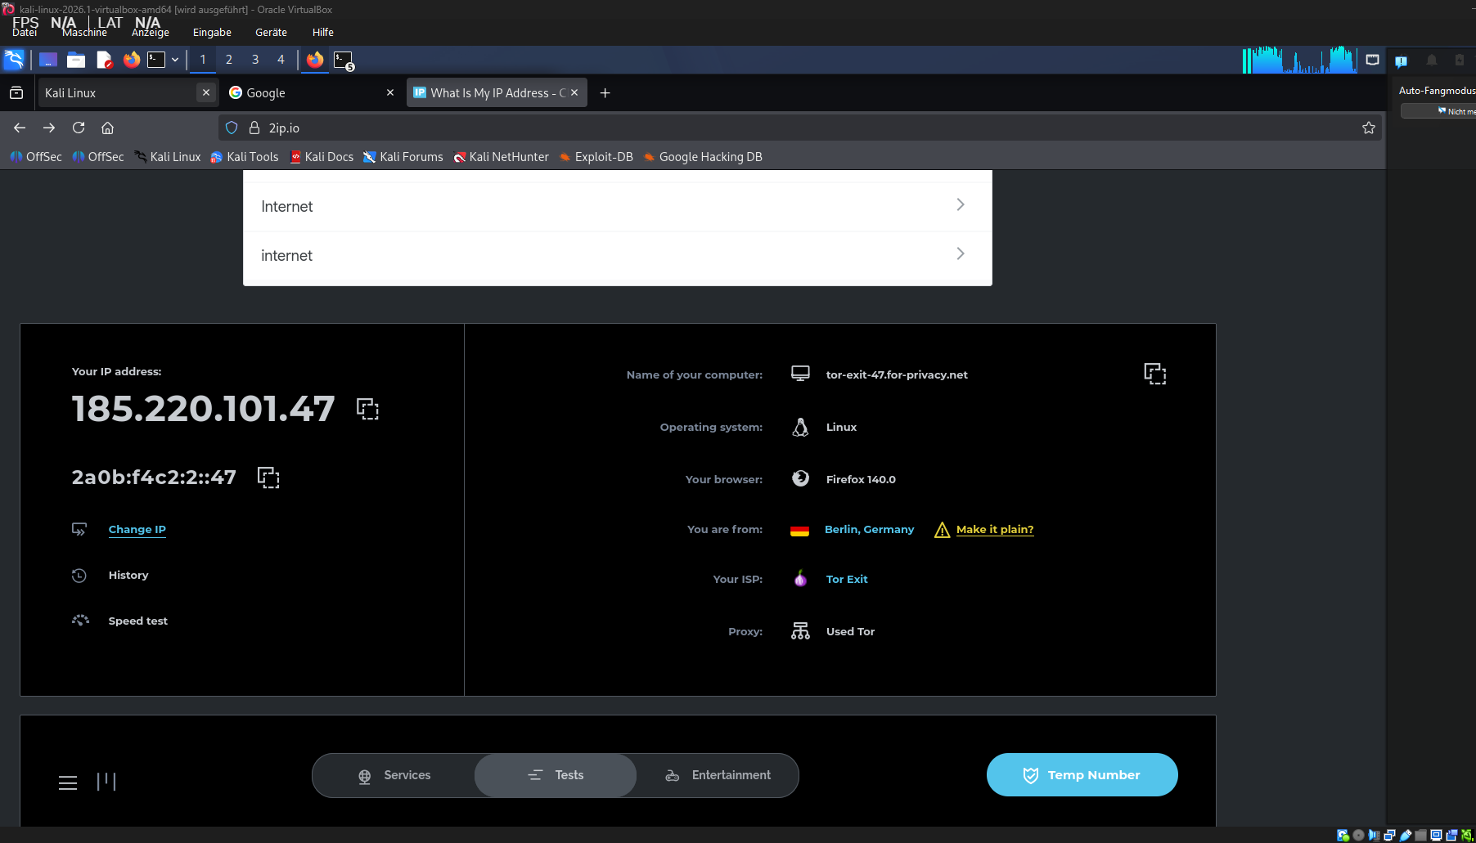

111111111111111111111111 Video and KI
In Kali Linux
locate proxychains
222
sudo vi /etc/proxychains.conf
sudo nano /etc/proxychains4.conf
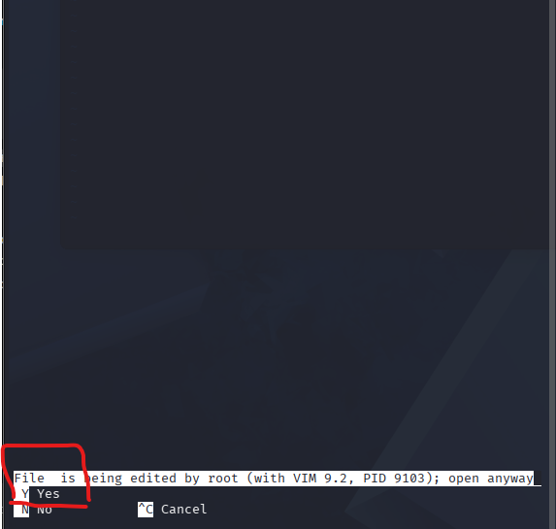
Press Y to cutinio
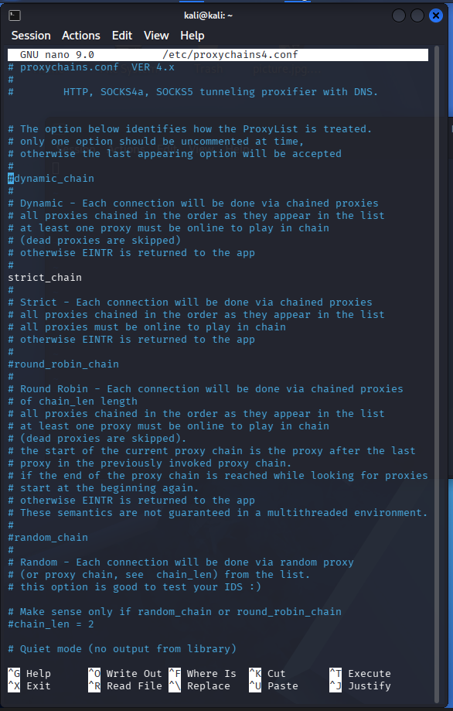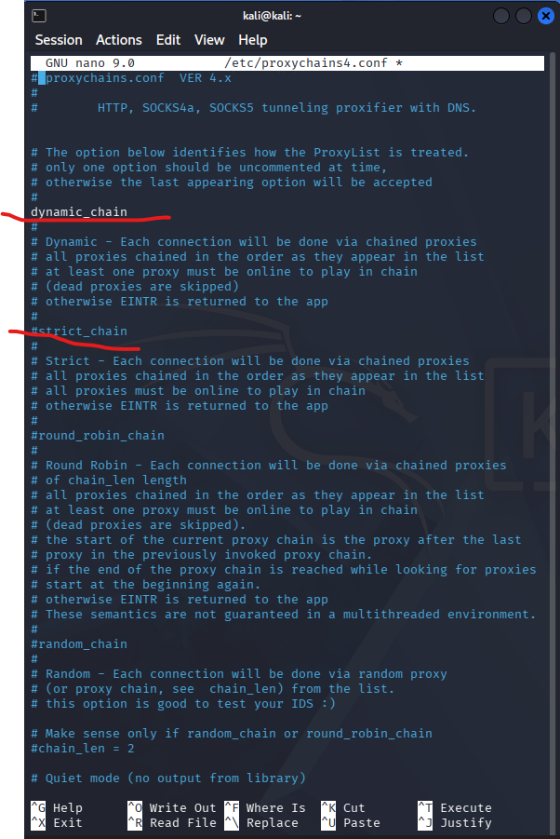
Press I for insert und make it so
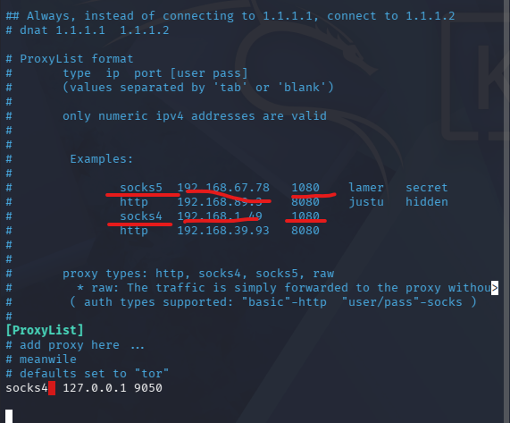

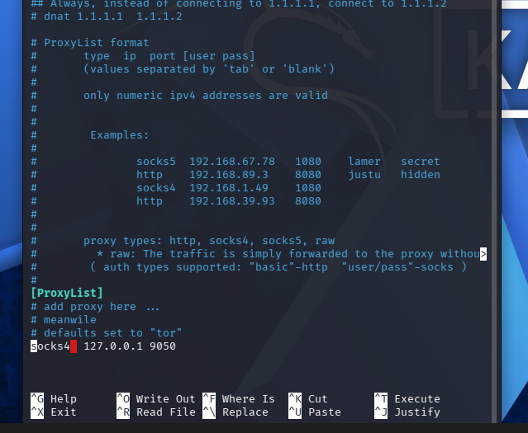

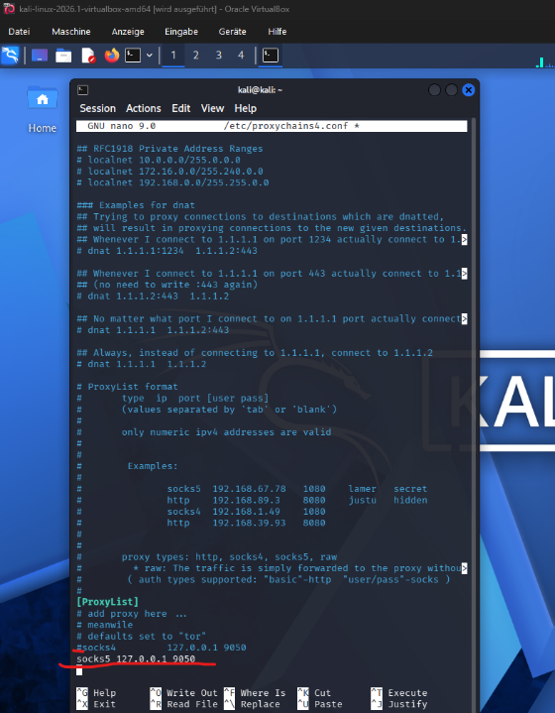
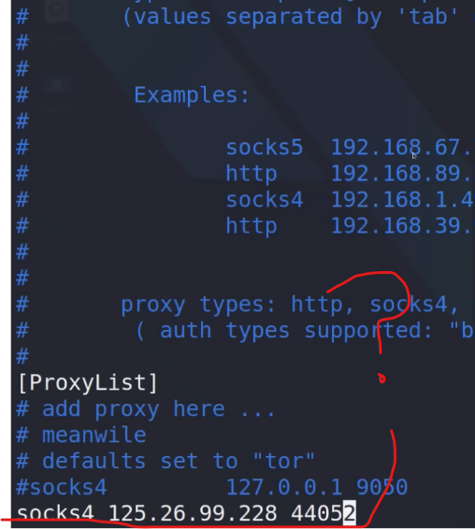

socks5 127.0.0.1 9050
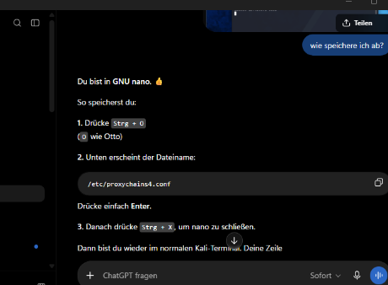
press in the end :wq
11111
press in the end Strg + O
2222
And then Strg + X

Prüfen11111111111

In kali Linux
ss -lnt | grep 9150
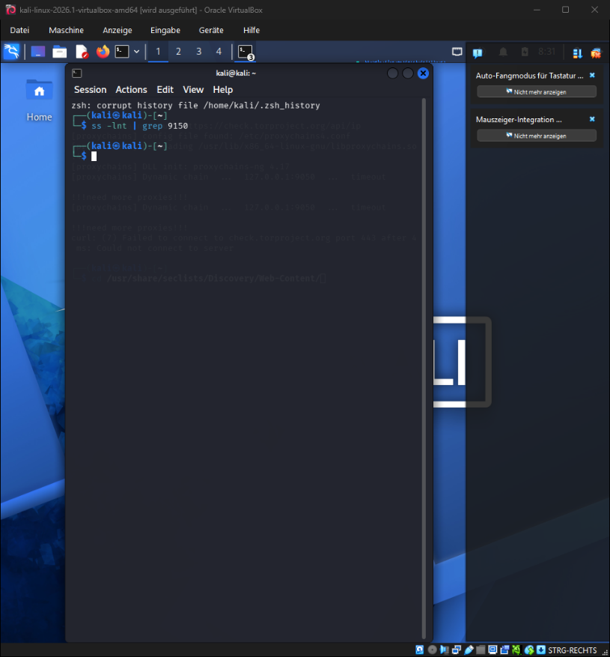

Nothing is it is free and jusable

In kali Linux
sudo nano /etc/tor/torrc
222222
SocksPort 9150
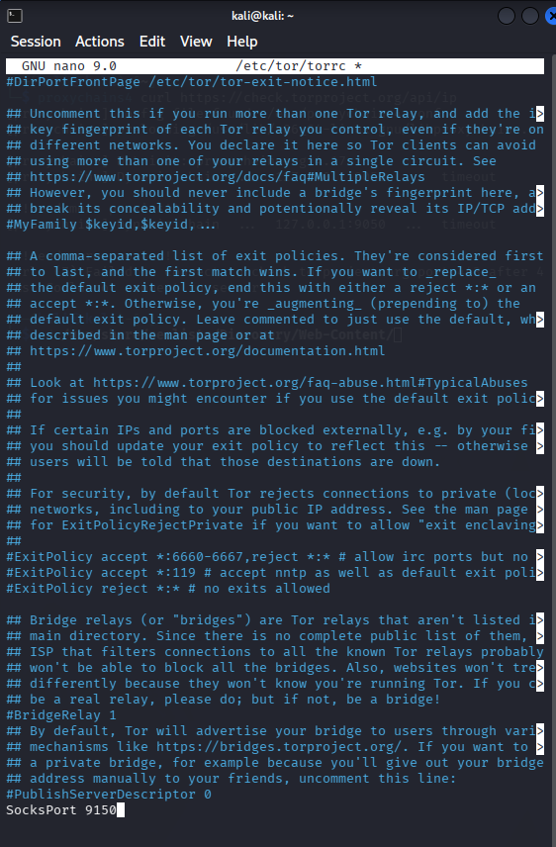

press in the end Strg + O
2222
And then Strg + X
33333333
sudo systemctl restart tor
44444444444
ss -lnt | grep 9150
kommt nichts
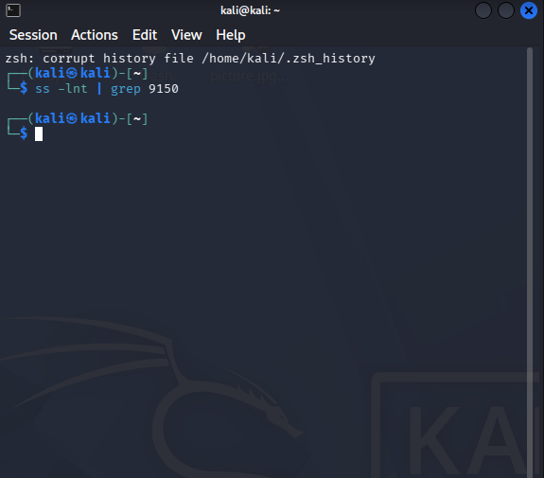

In kali Linux
sudo systemctl restart tor

sudo systemctl status tor
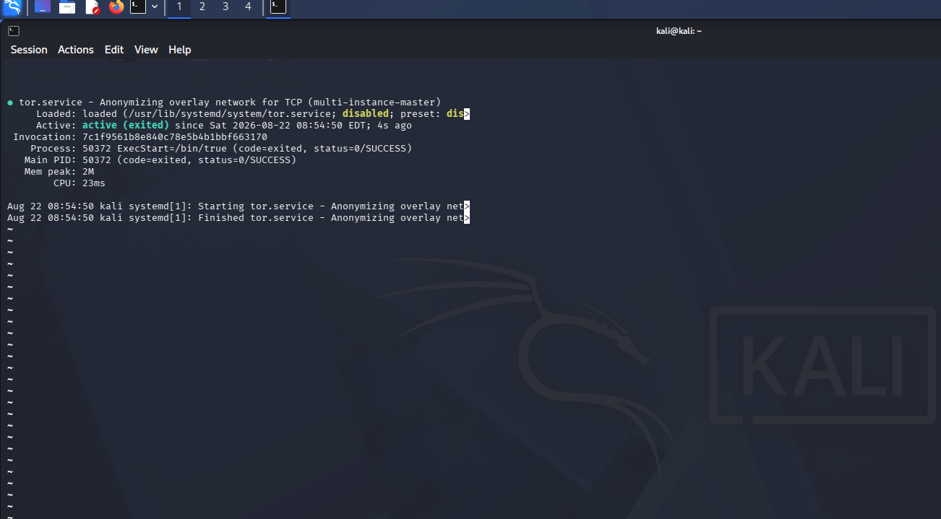
IN Kali Linux
sudo systemctl restart tor@default
222222222
sudo systemctl status tor@default
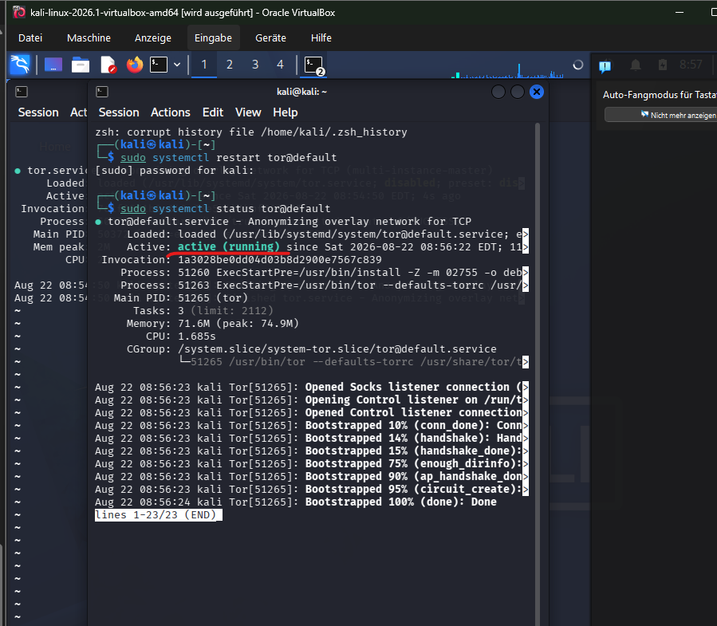
333333333333
ss -lnt | grep 9150
44444444444444
55555555555555
IN kali Linux
sudo ss -lntp | grep tor
777777777777
sudo ss -lntp | grep -E '9050|9150'
8888888888
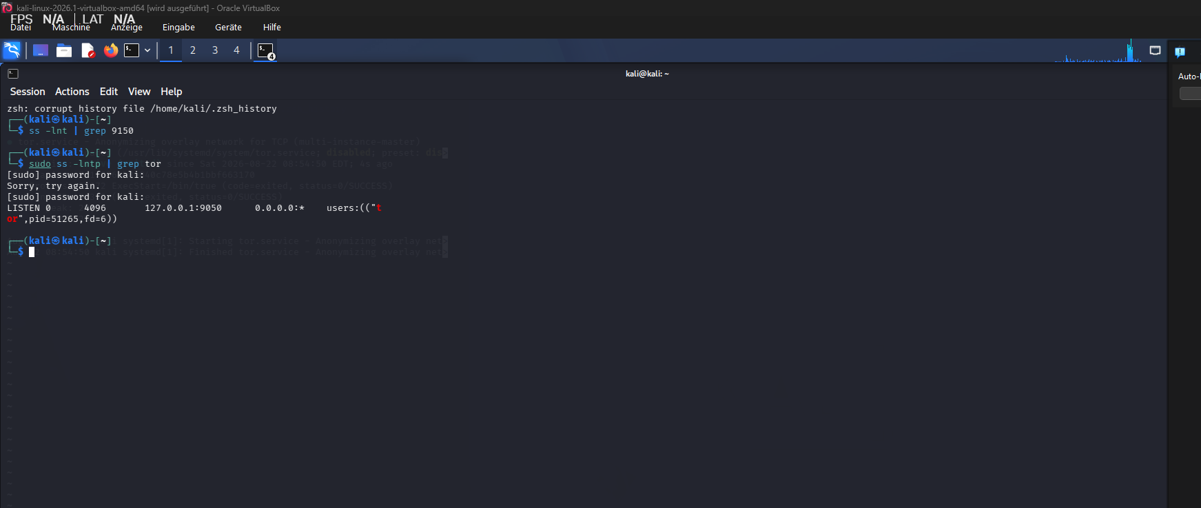
888888888
IN Kali LInux
grep -Rni "SocksPort" /etc/tor/
99999999999

sudo nano /etc/tor/torrc
1010eintragen unten
SocksPort 9150
11 11 11 111 11 1 111111 11 11
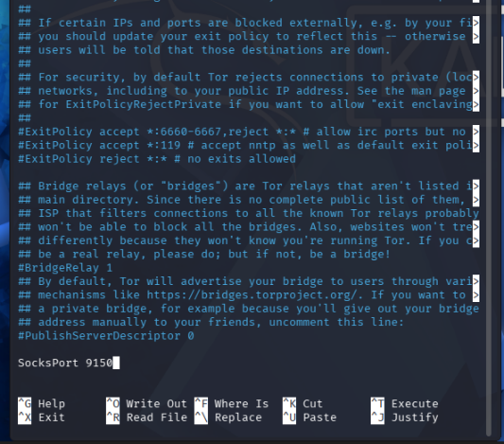
1 Press Strg + O
2 Press Enter
3. Press Strg + X

4. Press Y
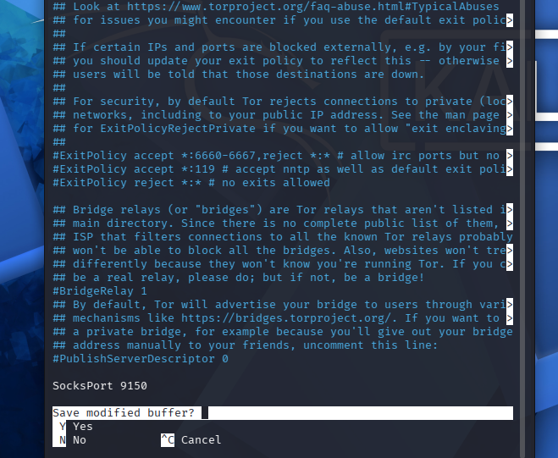
In Kali Linux
sudo systemctl restart tor
22222222
ss -lnt | grep 9150

333333333333333
Showes if its lisening
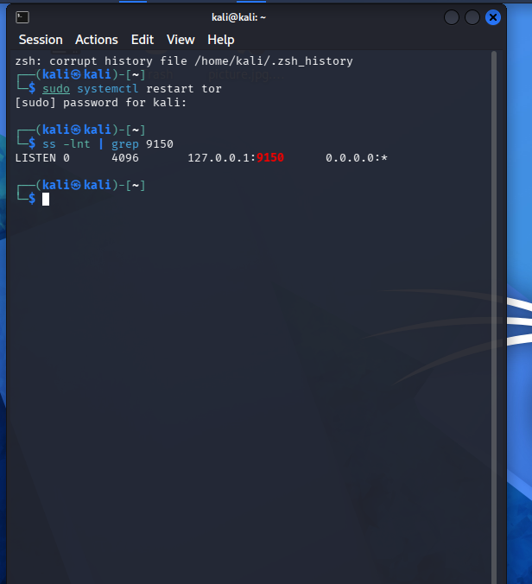
4444444444444

In Kali Linux
sudo nano /etc/proxychains4.conf
2222222222
socks5 127.0.0.1 9050 socks5 127.0.0.1 9150
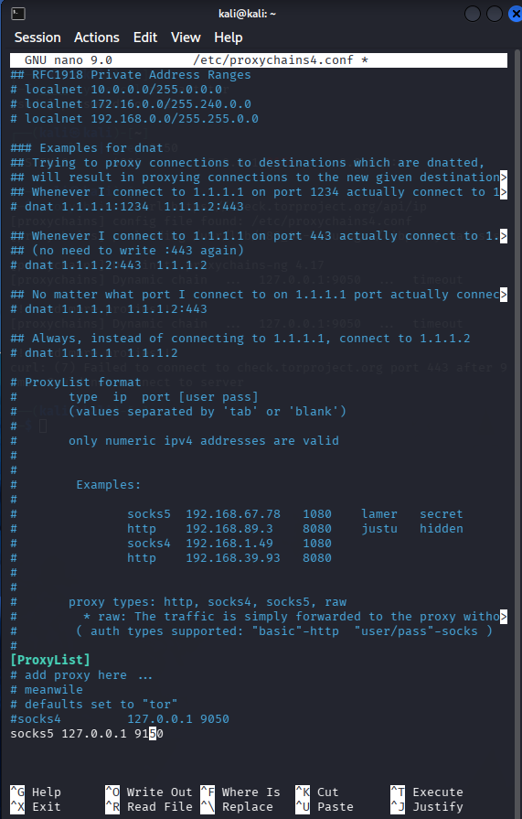
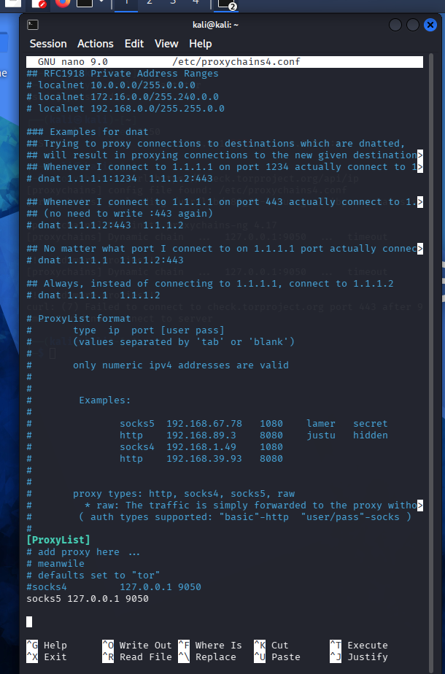

1 Press Strg + O
2 Press Enter
3. Press Strg + X

33333333333333333333333
Connection right
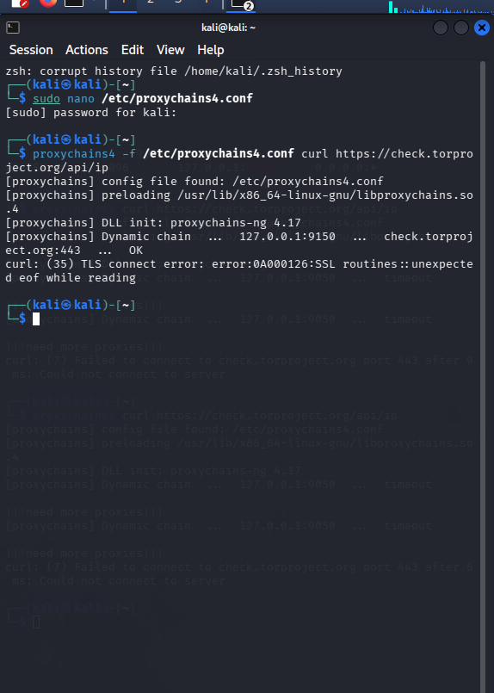
44444444444444
IN Kali Linux Test
curl --socks5-hostname 127.0.0.1:9150 https://check.torproject.org/api/ip
55555555
curl --socks5-hostname 127.0.0.1:9150 https://check.torproject.org/api/ip
777777777777777
sudo systemctl restart tor@default
88888888888
ss -lnt | grep 9150

99999999999
curl --socks5-hostname 127.0.0.1:9150 https://check.torproject.org/api/ip

10101010101010101010101010101101001000000
proxychains4 -f /etc/proxychains4.conf firefox
proxychains4 -f /etc/proxychains4.conf firefox
proxychains4 -f /etc/proxychains4.conf firefox https://www.google.de
proxychains4 -f /etc/proxychains4.conf firefox https://www.google.de

2222222222222222222222222222222 Ki
sudo apt update
2222222222
sudo apt install proxychains4 tor
333333333333
sudo systemctl start tor
4444444
systemctl status tor
55555555
kali@kali:~$
6666666666

